Monday, March 28, 2016

Research results as of this morning:

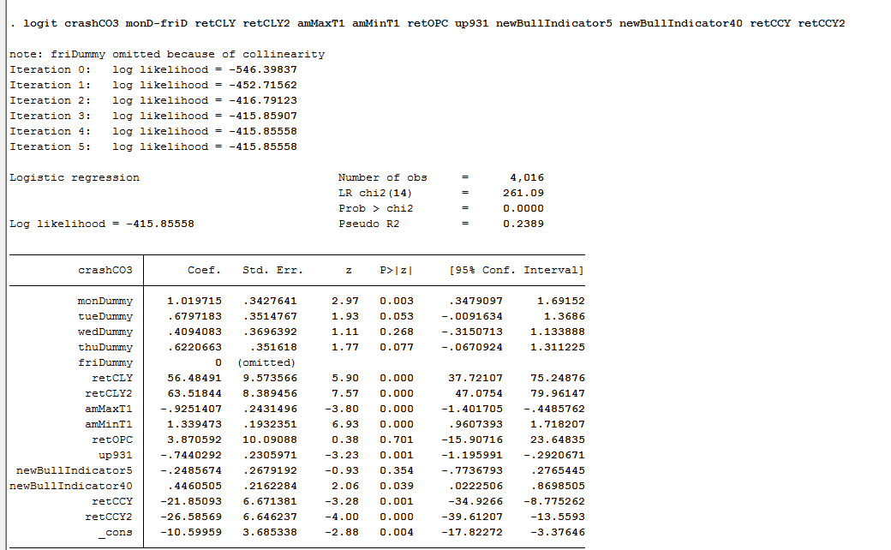

This logit model has a ROC of 86%, predicting retCO<-0.03.

The results include that yesterday and day before yesterda's retCL increases the chance of crash.

Cuing to buy at 9600 at the day's low.

Bid was filled at 11:18, since this is the day's low, the positioning feels OK.

Market took a plunge later in the day.

The issue today is with amMaxT being too early before 10 and the lackluster market caused people to be scared and exodus started in the afternoon when the daylow was broken.

Strategy needs to be developed that deal with when can you keep buying and when you cannot.

Today, it is intuitive to stop buying in the afternoon. However,

Last buying point needs to be further researched.

The probability was against you in the afternoon.

It is mandatory to go one step beyond the current level to the next level, which is to prevent these catastrophic crashes. Today given the AM high, I doubt it would be OK to buy at 11:15. The methodology is problematic.

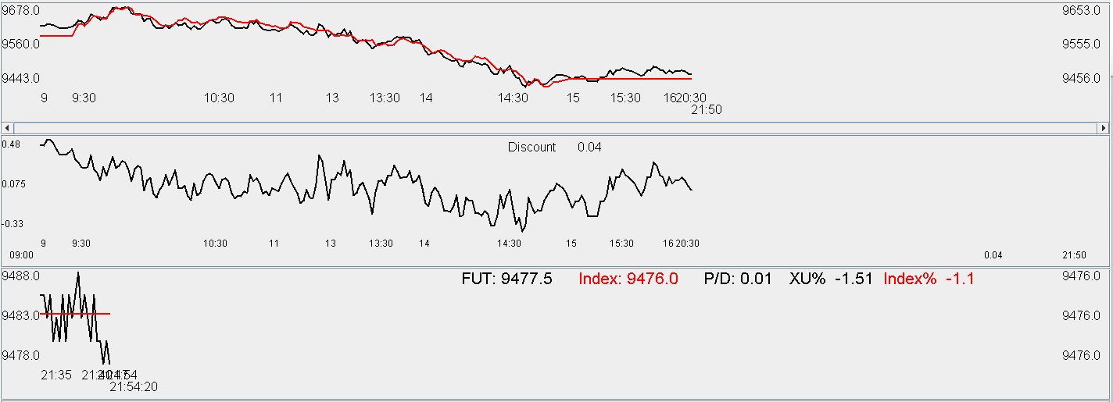

As can be seen from the charts, futures are trading at flat.

Mar 29 2016 Tuesday

Position was entered at 9490.

Am high was broken near 10pm. Given yesterday's close near the lows, the probability of the high being in the afternoon is over 50%. Therefore it is decided to hold the position until at least early afternoon.

Another lot was entered at 9450. Overall delta exposure is 300k, which is 2/3 of the overall position. Since this position is quite heavy, half of it needs to be liquidated going into tomorrow. The limit of the position has been topped out at 4. This is what was decided for the experimental maximum position. There might be news/events which are unknown from my end and such probability needs to be prevented. Overall delta of 300k HKD is comfortable at this level.

Conditional distribution of the dayMinT is shown as follows. The chance of a catastrophic day is quite big, with heavy position it is not that ideal. However, there should be a rebound of 1% on average from the low to the close. I am trying to capture this amount.

It is interesting how weak the market is while it was super strong just 2 weeks ago. The greed and panic which characterizes the market is very interesting. Essentially, the market is giving back what it has gained during the bull market of Mar 16-Mar21.

Upon inspecting the graph, the level broke the low of last Thursday. It is drop of about 4% from the top observed last Monday.

If index goes down 10% today I will drop 7%. This will be 30k HKD. Be prepared for this case. If markets don't rebound at 2pm, half the position will be cut to bring the overall exposure back to 30%.



Market was strong in the first half of the session then took a dive towards the close. Market is extremely weak and this Thursday will be tough. Efforts will need to be expended to liquidate the position tomorrow in preparation for Thursday. Going into Wednesday with 3 lots is barely acceptable. Be very careful of this Thursday as the weakness will be most ostensible then.

Market closes at the low continuously for two sessions and tomorrow we might be able to see some minor recovery, but make sure to sell position whenever possible and go into Thursday with maximum one lot or no position. Markets are hitting new lows every day and it is best to keep cutting position until sentiment improves.

Today it was not easy to trade. Over two days the market has dropped over 2% and it is crashing into the close. Do not add position anymore.

In hindsight, the position was a little heavy for Tuesday. Some unloading will need to be done tomorrow. **If market remains weak, shorting on Tuesday and Thursday will be implemented.** Currently the market is clearly in a very weak state.

Upon observing the charts over the two days, the issue is that one lot should have been entered at yesterday's close (**important positions lacking positioning)** and it should have been exited today in the morning. **Secondly, day trading positions need to be quickly monetized whenever the time is ripe.** Quicker sells need to be prioritized rather than greedy sell, because currently the market is downward trending.

The loss of steam could have been seen last Monday where the market peaked in the early AM, from Tuesday to Thursday it was uniformly going down. This week, Monday opened up and remained extremely weak throughout the day, and Tuesday was also a painful session. Extra care need to be taken on Thursday.

If market loses steam on Monday, be extra careful as it is the day where investors are most excited. They tend to overbuy on Monday because of their gambling nature, especially if the market is going up and overbuy on Friday in anticipation of the news release over the weekend. On Tuesday, most investors have position and they need to sell, which creates downward pressure on prices. On Wednesday, investors need to accumulate position again and they buy. On Thursday, same story continues with more sellers than buyers.

Key logistic regression today:

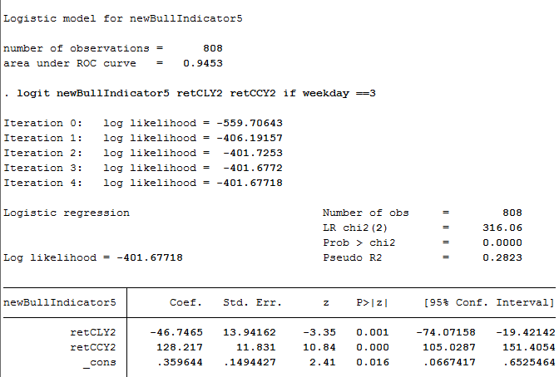

In this regression, we are trying to estimate whether any given close will be higher than its 5-day moving average. The most significant factors are how much was the return the previous day and how much was the rebound from the low yesterday. While true returns (retCC) was helpful, false returns (rebound from low to close) was heavily penalized. A day is most heavily penalized if the retCC is small and underwent a huge intra-day swing.

Days like Mar8 and Mar9 were good examples of small retCC and huge retCL. This was quickly punished on Thursday. RetCC is three times as important as retCL, so the retCL needs to be at least 3 times the retCC to exert a negative influence.

Look at the activity of traditionally strong and weak days. Monday, Wednesday, Friday are traditionally strong days. Tuesday and Thursday are traditional weak days. If an above/below average performance is achieved on these days, these might demonstrate a tell-tale sign of the current market's bull/bear nature.

How to avoid big losses?

Choose position size wisely.

Chance of crash drastically decreases with the AM high occurring later and later on in the day.

Be extra careful on Monday and Thursday.

Be extra careful if the previous day's retCL is considerably more than the retCC. Worst case scenario is a flat retCC and a huge retCL.

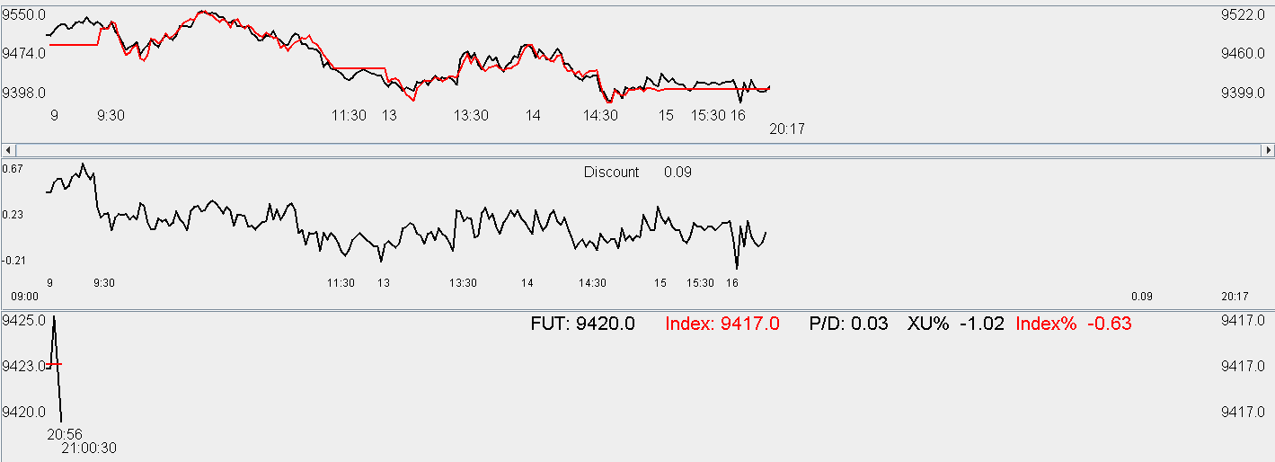

Market keeps heading lower. Be very careful going into tomorrow.

**Wednesday Mar 30 2016**

Yellen was dove last night, US was up.

Hold position until the close because last time Yellen decided to delay cutting rates, markets had a series of rally.

Markets had a brief outburst at the open, with shorts covering due to Yellen's dovishness. Today it will be tough for the shorters.

It is important to come up with the kernel distribution of the retCC.

Market opens up and rushes up. Nothing will be done at the moment. Keen observation of the markets is needed. XU futures are at a 0.2% premium. Market goes into greed mode.

1016 update: dayMax has 2/3 to be in the PM. Future are resilient.

Distribution graphs for retCC, and the positive/negative ratio.

Monday: (44%/56%) Tuesday: (43%/57%)



Wed: (46%/54%). Thurs: (54%,/46%)



Fri: (48%/52%)



As can be seen from the above graphs, Monday has 15% of cases outside of the -2.5%~+2.5% range, making it the most volatile day of the week. The positive cases are more numerous than the negative cases.

On Tuesday, in general there are more positive cases than negative, but there is a lack of upside potential and this makes the average return on this day negative.

On Wednesday, downside potential is the smallest of the five days. The upside potential is reasonable at 5% above +2.5%.

On Thursdays, downside potential is most exaggerated out of the 5 days, with 6% less than -2.5%. There are also more negative than positive sessions. This is the most suitable day for shorting out of the 5 days.

On Friday, there is a slight advantage for the long.

RetOPC and retCL analysis:

1349 update:

I don't understand why the futures are trading at a 0.35% discount on the last trading day. There might be transaction cost to settle the futures vs. the cash close, or the cash close will be lower than what the current cash print suggests? The futures goes down whenever it has a chance and the discount is 0.34%. It seems like the market is afraid of something.

People might be long rolling futures into tomorrow. The April futures is trading at 9562, and the mar future is trading at 9542. The fact that the roll is trading at a premium shows that there are a lot of long positions to be rolled, and the shorts are letting their positions expire. The future is now at a 0.4% discount, which I don't comprehend. The only reason I can think of is the rolling.

There is 54% chance that the dayMax will appear in the final half hour, and 70% chance it will appear after two. It will be quite tough for the long rollers.

The April futures is trading at a premium broke the highs and keep rushing up. The roll is very difficult to manage at this point. The roll is trading at a 26 bps premium. The Apr futures is trading at a premium.

Sold 2 futures at 9590, the last future is to examine how the settlement process works.

Tomorrow I will have no position, which is not very ideal, but tomorrow is Thursday, looking to build some position tomorrow morning.

I won't sell the futures anywhere less than the fair, which is currently 9581.

Around 14:13, sold the future @ 9590, which was around 10bps discount. The market is basically saying if you want to long roll, you must pay a premium.

1424 Update: futures trading at 23 bps premium. The march futures has caught up with the cash

1509

March finished. The indices closed around the highest level. Two lots were sold off early but it was fine. I have no position going into tomorrow which is Thursday. April futures are trading at a 40 bps discount in anticipation for the US rally today. Market positioning has turned bullish again.

The dovish sentiment embedded in Yellen's tone serves to support global markets. China's two days of lackluster performance also contributed to today's explosion.

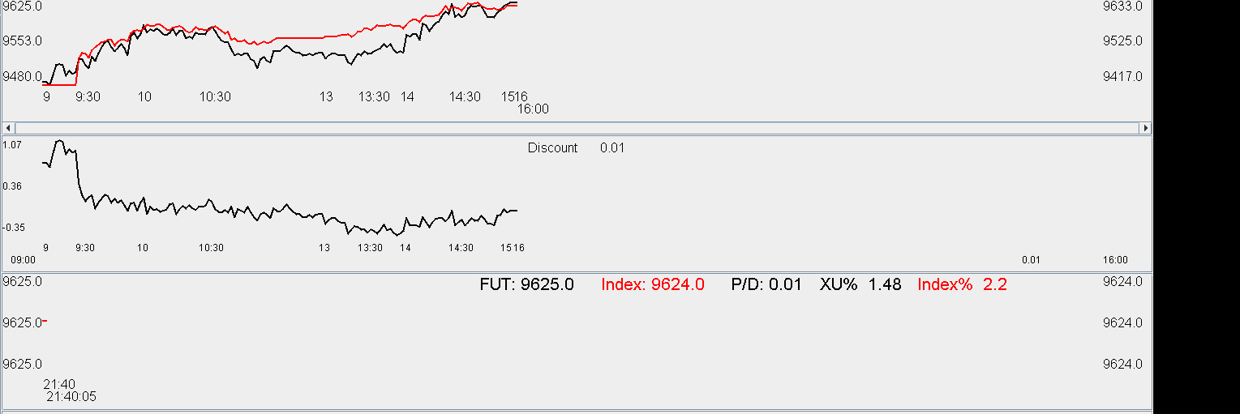

Today's rally was due to Yellen's dovish comments overnight. It was positive that the position was held pretty much until the day's close. Wednesday also played a part in the bullishness.

Thursday, March 31, 2016

Market went up over 2% yesterday. Going into Thursday, the market is predicted to be slightly bullish. DayMinT: 52.5% in the AM, 47.5% in the PM. Today is not a normal bearish Thursday so look for opportunities to enter when the discount is suitable.

The April future is trading at 40bps premium. Since it is Thursday, there will be

RetCO is negative today with a positive retOPC.

RetLO: -1.37%.

RetCL: +1.23%.

RetCO: -0.14%.

There will be a dip and there will be a recovery, with the average day's return negative.

The premium is persistent at 40 bps. Therefore it will not be chased here.

Got hit at 9625, which is higher than the fair. The low has been broken at around 10:30 and the expected retCO is -73bps. RetCL is 1.17% while retLO I s -1.9%. RetCH is -1.2%.

Market is weak as expected, the best chance was short into this morning. This shows that yesterday's rise was ephemeral and it does not change the long run trend in EM.

Market just broke the lows after 10:45. The distribution is not that good today. Markets are in fear. Markets are back to a discount.

The expected CL is only 0.97%. Today on average the market will drop 1.1% (RetCO). Tuesday is taking its toll. I am trapped at this point and will not add position until later in the day. Some mtm will have to be endured on this position.

Position was exited at flat. Although there was a rebound towards the end of the AM session, the AM max and min distribution is not so auspicious. Today's min has 50% of being in the first hour of the PM, 44% of being in the second half of the PM. Average rebound is about 90bps. Today's true opportunity was to short into the future at 1% premium.

The strength that was demonstrated by the dayMax achieving 13:28 is construed as being strong. Therefore I am bidding at 9600 and I got my position at 1406. The theory is as follows. There is a latent variable which dictates market sentiment. Let's call it weak/strong (WS). The key is to determine P(WS|features). Using a Naive Bayes model, the conditional probability is equal to

P(Weak|feature1,feature2,…featureN)

= P(Weak)*P(feature1|weak)*…P(featureN|weak)/Normalization Factor

P(high achieved in the pm|weak) is very low, it is about 20%. This means the latent variable is not weak.

The feature vector includes [Thursday, amMaxT1, amMinT2, retOPC, retCCY, dayMaxT1, dayMinT1].

Market started rebounding at around 2:30. This confirms with the latent variable hypothesis. The latent variable is responsible for generating probability distribution. Given what we see, we try to deduce what the true state of the model.

The question is how to identify the latent variable. It is not very intelligent to call a market bull or bear (dichotomous), it is better to have a probability associated with a state.

All in all, in retrospect of today, markets were unduly bullish (premium of 1%) at the open. Markets gave back its entire premium. Due to the high opening, markets entered into a fake rally around 13:30, it was surprising that this broke the day's high, which was interpreted by me as a sign of latent bullishness. Markets pulled back towards the 14:00 and a position was entered at this level. It would be already acceptable if this position doesn't lose money, because the purpose of the position is to prepare for tomorrow.

After the close, markets panic and futures sell into a discount, showing market has given up on the bullish spirit as of yesterday. The buying points were decent today. The first selling point was a bit wrong because with a late AM rally, there would be afternoon bullishness.

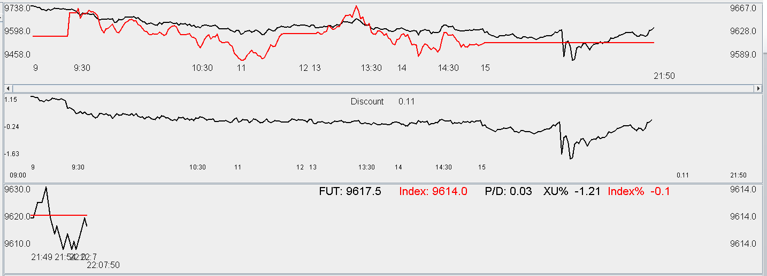

SP downgraded China today, which caused the market to crash in the evening session, however, the market slowly recovered back to fair value.

4/1/2016

The first quarter is over, portfolio is up 2% since the beginning of this year.

The overall performance has been vastly better than the last quarter.

Methods to avoid crashes should be continously researched. Position sizing strategies need to be continuously researched.

Market is lackluster. Markets are fidgety and let's fall back on the default retCC distribution: the first graph is for all retOPC, the second is for retOPC>0. It is OK to hold through today. It is important to note that having a retOPC>0 reduces the chance of a crash.



Morning session was weak, daily low was reached after 10am. The max in morning prob is 60%.

The probability is not in trading's favor today. Average rebound is only 80 bps. Cut position and prepare to leave. Being cautious on the right side of probability has to be done. Markets don't want to go up at all. Markets are unexpectedly weak. Cut position to be the bare minimum.

Markets are extremely weak. I have built position at 9477 and 9570. 3 lots on an extremely weak day. The drop was a little bit exaggerated. There might be news that I am not aware of. Picking up position here anyways. As the position has been maxed out, no more will be added. There might be need to cut loss next Monday if market opens low and starts heading lower, if that happens cut 2 lots and wait until later. If it continues to be weak during midday cut everything. Today I am trading at 50% position size because it is Friday and there are relatively fewer crashes.

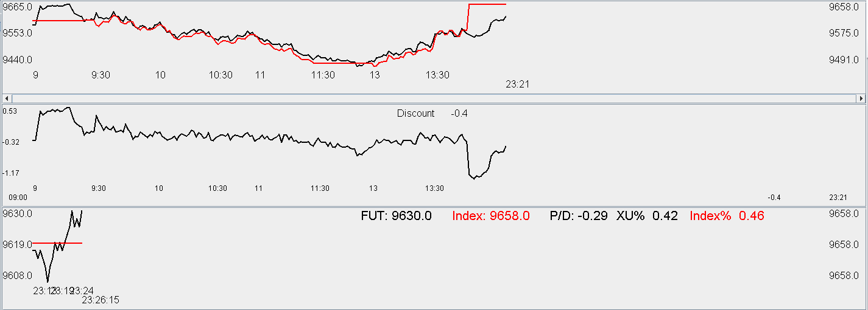

**Weekly Review:**

Monday to Wednesday:

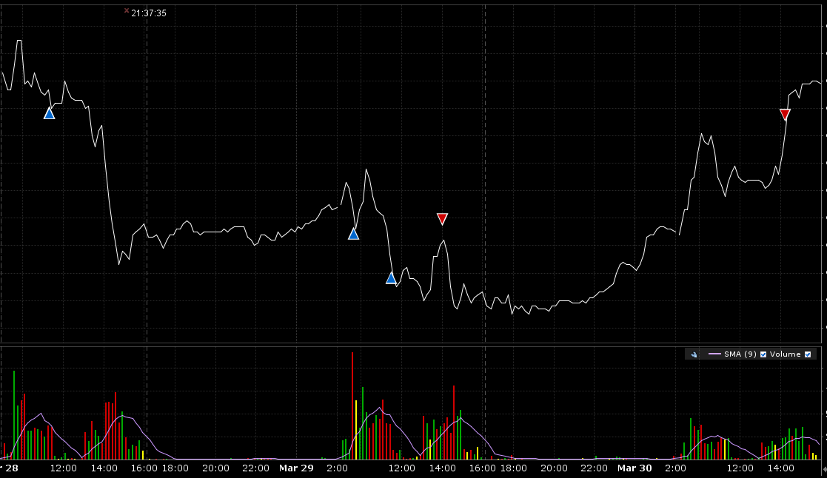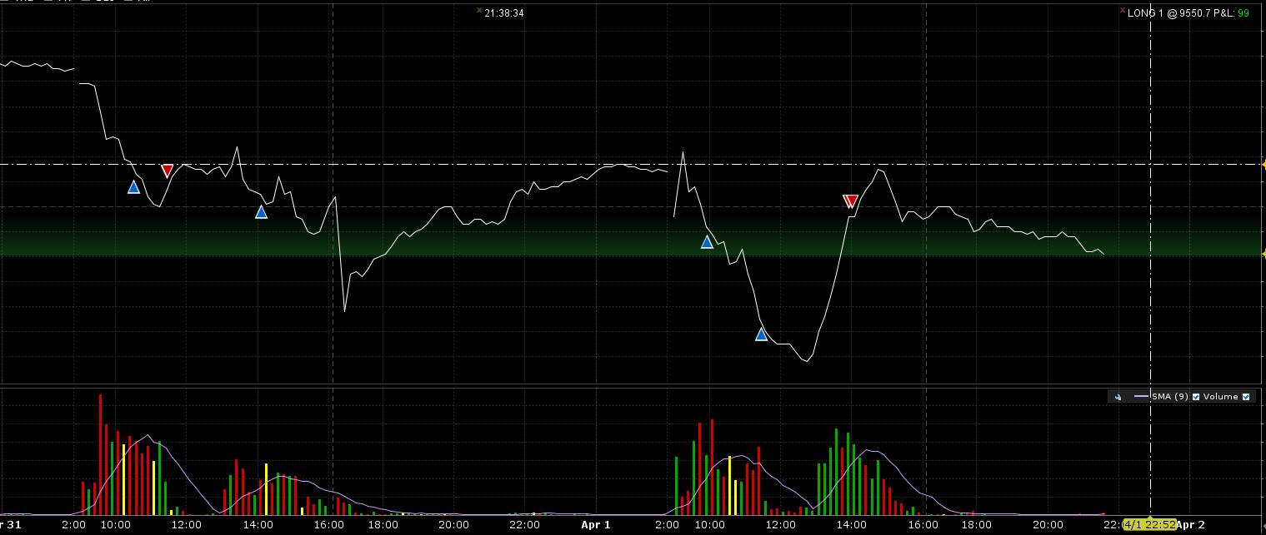

Trades:

|  |  |  |  |  |  |  |  |  |  |
| --- | --- | --- | --- | --- | --- | --- | --- | --- | --- |
|  | MAR 28 11:18:33 | MAR16 Futures | XINA50 | BOT | 1 | 9600.00 | SGX |  |  |
|  | MAR 29 09:37:35 | MAR16 Futures | XINA50 | BOT | 1 | 9490.00 | SGX |  |  |
|  | MAR 29 11:28:41 | MAR16 Futures | XINA50 | BOT | 1 | 9450.00 | SGX |  |  |
|  | MAR 29 14:00:05 | MAR16 Futures | XINA50 | SLD | 1 | 9495.00 | SGX |  |  |
|  | MAR 30 14:12:45 | MAR16 Futures | XINA50 | SLD | 2 | 9590.00 | SGX |  |  |
|  | MAR 31 10:30:38 | APR16 Futures | XINA50 | BOT | 1 | 9625.00 | SGX |  |  |
|  | MAR 31 11:27:33 | APR16 Futures | XINA50 | SLD | 1 | 9630.00 | SGX |  |  |
|  | MAR 31 14:06:07 | APR16 Futures | XINA50 | BOT | 1 | 9600.00 | SGX |  |  |
|  | 09:55:57 | APR16 Futures | XINA50 | BOT | 1 | 9570.00 | SGX |  |  |
|  | 11:27:47 | APR16 Futures | XINA50 | BOT | 1 | 9477.50 | SGX |  |  |
|  | 13:55:38 | APR16 Futures | XINA50 | SLD | 1 | 9600.00 | SGX |  |  |
|  | 14:01:29 | APR16 Futures | XINA50 | SLD | 1 | 9600.00 | SGX |  |  |

**Monday:**

Incremental position was missing in the afternoon around 2:45pm. Monday was very weak with morning high before 10am. Note that if the incremental position was entered, it would need to be exited promptly the next morning to cut risk. It would not be wise to go into Tue/Thu with a sizable position.

**Tuesday:**

Following a weak Monday, the Tuesday was equally weak, closing at the lows again. Night session was very bullish due to Yellen's dovish comments, markets went into greed mode immediately on Wednesday.

**Wed: (PnL: +500)**

Going into Wednesday with 3 lots, this was a decent size for an important day.

Wed was the expiry date for Mar futures. This day was characterized by lot of market participants scrambling to long roll their futures. Apr futures traded @ 1% premium persistently in the PM session, and the Mar futures was trading consistently at a discount until a few 10s of minutes before 3pm. (Thursday turned out to be very weak and the premium was all lost).

**Thurs: (Trade +0)**

Markets were weak due to Thursday.

In hindsight, Thursday started with 1% premium and opened high, this was a bit risky to short. The liquidating leg of the first trade was @ 1125 amidst a last minute AM rally, this was too early. With a rally like this, the PM session will experience a fake euphoria in early PM. Selling during euphoria would be the appropriate time.

After the close, SP downgraded China's credit rating, which quickly caused XU to drop precipitously. However, markets soon climbed back as this does not seem to have any material impact. A position was missing near 16:40 pm, as people were panicking at this point.

**Friday: Pnl (Trade: +150, delta: 0)**

The afternoon rebound was impressive, which confirmed with the latent variable hypothesis which postulated that the underlying probability generating variable is bullish. This is the first few cases where position is built at a key position.

**Positives:**

Some attempt at buying at the point of panic, however, there was under-utilized opportunities.

Some attempt at position sizing. 3 lots was held going into Wednesday and 3 lots were held intraday on Friday. The position sizing on Wed and Fri worked out well. On Thursday the position was intentionally light, which was also good.

**Negatives:**

No shorting on Thursdays. The shorting needs to be regularized. With the Thursday distribution in mind, take chances at shorting (start with only Thursday for now).

**Improvements:**

Although improving, key panicking position need to have a position entered. Positions need to be sold at the open if generating a return overnight. For example, picking up at Thursday 16pm and selling @ Friday 9:15am. Buying @Monday 16pm and selling at Tuesday 9:15am.

**Thurs: actively look for shorting opportunities, as the day has a negatively skewed distribution.**

If market rushes up during early morning session, make sure to liquidate unless it is (Wednesday) with an external probability changing event.

**Misc:**

This week was rather typical. Tuesday and Thursday was weak, Wednesday was strong which followed normal principles. Monday was very weak with an early am high and a gruesome PM session. Movement in the IH ETF (in the Thursday PM) made it obvious that there was an underlying bullish torrent driving the market, which demonstrated itself again on Friday.

Chain of strengths:

Weak Monday -> Weak Tuesday

Weak Wednesday -> weak Thursday

Identification of market sentiment needs to be keener: identify market fear, greed, emotions, etc. Be mindful of the underlying latent variable which is generating the distribution, whether it is bullish or bearish.

**Percentile Analysis:**

Mon: 40% below mid, 60% above mid. (Extremes: 71.5%, mediocre:28.5%) Monday has the most values in the extremes out of the five days, which means it is very volatile and extreme.



Tue: 40% below mid, 60% above mid. More values in the mid unlike in the Monday scenario (>70% in the two extremes) (Extreme: 65%, Mediocre: 35%)



Wed: 42% below mid. 58% above mid. Extreme: 67% in the extreme, 33% mediocre.



Thu: 51% below mid, 49% above mid. Extreme: 66%, mediocre: 34%. Thursday is only day where shorting has an advantage.



Fri: 44% below mid, 56% above mid. Extreme: 60%, mediocre: 40%. Friday has the least amount of extreme percentiles in the five days.



Rebound strength: RetCL:

Mon: 41% rebound > 1%.



Tue: 40% rebound > 1%.



Wed: 42% rebound >1%. (very strong rebound)



Thu: 35% rebound > 1%. Very weak rebounds.



Fri: 37% rebound >1%. Not strong rebounds.



Rebound analysis also shows that Thursday is the weakest day in terms of rebound. Short whenever the index peaks on this day.